Read Now: Uncertainty in Measurements Date: _________________
When we measure something in science, the value is not always exact. This is because:
- our reading might be slightly off
- the equipment is not perfectly precise
This small amount of doubt is called uncertainty.
Uncertainty tells us how confident we are in a measurement.
It shows how much the value could be higher or lower than the result we write down.
Every measuring instrument has a smallest scale division.
- The uncertainty is usually half of the smallest division
- This is because we estimate between the lines
Example:
A ruler has an uncertainty of ±0.5 mm. this means if someone measures a length as 25.0 cm, the true length could be slightly bigger or smaller, between:
24.95cm and 25.05 cm
24.95
25.05
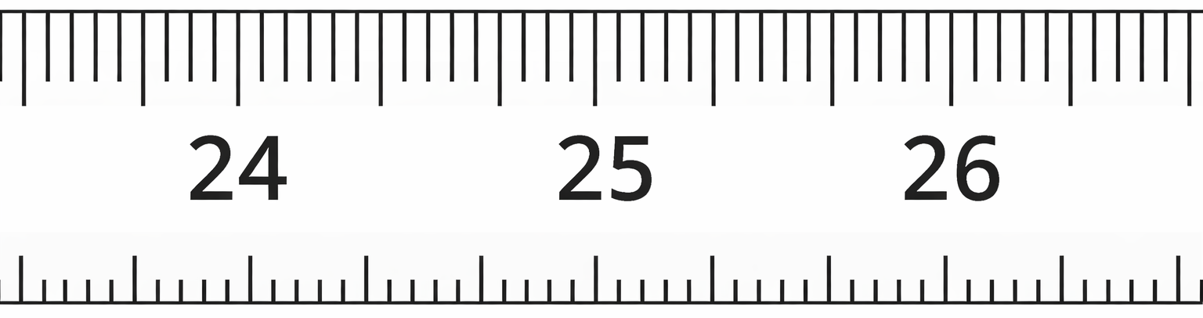
Questions:
1. Why is a measurement not always exact?
A. The object changes size B. Our reading might be slightly off
C. Numbers are always wrong D. Science is confusing
2. What is the name given to the small amount of doubt in a measurement?
3. What does uncertainty tell us about a measurement?
4. When using a measuring instrument, how is uncertainty usually estimated?
5. A ruler measures to the nearest 1 mm. What is the uncertainty?
6. A bridge is being built. Engineers take measurements to make sure it is safe. What could happen if a measurement is not exact?

Read Now: Concentration Date: __________________
Concentration tells us how much solute is dissolved in a certain volume of solution.
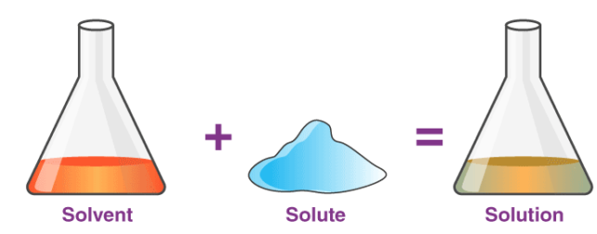
A solution with high concentration has a lot of solute in a small volume.
A solution with low concentration has less solute in the same volume.

Example
If two beakers contain the same amount of water:
- The one with more salt has a higher concentration
- The one with less salt has a lower concentration
Concentration is measured in:
g/dm³
This means grams of solute per dm³ of solution

Remember
- Solute = the substance that is dissolved
- Solution = solute + solvent
- Higher concentration → more particles in the same volume

Questions
1. What does concentration tell us?
A. How hot a solution is B. How much solute is dissolved in a certain volume
C. How fast a reaction happens D. How heavy the solution is
2. What is the solute?
3. If two beakers contain the same amount of water, which one has a higher concentration?
4. What is the unit of concentration used in science?
5. Two solutions have the same volume. One has more solute than the other. Which solution has the higher concentration, and why?
How to calculate uncertainty

I DO:
Trial | Measurement (cm)
1 | 12
2 | 13
3 | 14
Find the uncertainty:
Step 1: Calculate the mean

Step 2: Calculate the range (biggest − smallest).
Step 3: Divide the range by 2 to get the uncertainty.
Step 4: Write the answer (mean ± uncertainty)

Trial | Volume (cm³)
1 | 15
2 | 16
3 | 18

WE DO:
Step 1: Calculate the mean

Step 2: Calculate the range (biggest − smallest).

Step 3: Divide the range by 2 to get the uncertainty.

Step 4: Write the answer (mean ± uncertainty)

YOU DO:
Trial | Length (cm)
1 | 8.0
2 | 8.2
3 | 8.1
Step 1: Calculate the mean

Step 2: Calculate the range (biggest − smallest).

Step 3: Divide the range by 2 to get the uncertainty.

Step 4: Write the answer (mean ± uncertainty)

1.

Trial | Length (cm)
1 | 10
2 | 11
3 | 12
Mean = ____________________
Range = ___________________
Uncertainty = ______________
Final answer:

2.
Trial | Time (s)
1 | 9.9
2 | 10.0
3 | 10.2
4 | 10.1
Mean = ____________________
Range = ___________________
Uncertainty = ______________
Final answer:

3.
Trial | Length (cm)
1 | 8.0
2 | 8.2
3 | 8.1
Mean = __________
Range = __________
Uncertainty = __________
Final answer:

4.
Trial | Time (s)
1 | 9.8
2 | 10.0
3 | 9.9
4 | 10.1
Mean = __________
Range = __________
Uncertainty = __________
Final answer:

Trial | Mass (g)
1 | 25.4
2 | 25.6
3 | 25.5
4 | 25.7

5.
Mean = __________
Range = __________
Uncertainty = __________
Final answer:

6.
Trial | Volume (cm³)
1 | 14.8
2 | 15.1
3 | 15.0
4 | 15.3
Mean = __________
Range = __________
Uncertainty = __________
Final answer:

7.
Trial | Time (s)
1 | 18.2
2 | 18.9
3 | 19.1
4 | 18.6
5 | 19.0
Mean = __________
Range = __________
Uncertainty = __________
Final answer:

